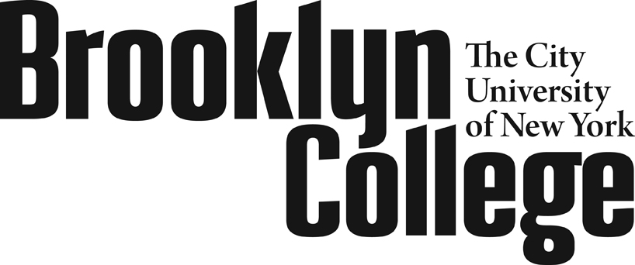

**Evaluation Conference Memorandum**

**Instructional Non-Teaching Personnel**

(College Laboratory Technician Series)

|  |  |  |  |  |  |  |
| --- | --- | --- | --- | --- | --- | --- |
| **Employee Name** |  | | | **Department** | |  |
| **Functional Title** |  | | | **Rank** | |  |
| **Evaluation Period** | | From: |  | | To: |  |

*Attach any supporting documents if necessary.*

1. **Description of Current Duties**

(Please indicate if there have been changes since the last evaluation.)

Click here to enter text.

1. **Performance of Current Duties**

(Refer to those duties not covered under Section 3.)

Strengths:

Click here to enter text.

Areas in Need of Improvement:

Click here to enter text.

Rate Performance:









Supplementary Accomplishments (Optional)

(Include any educational/professional accomplishments, service and activities through professional associations.)

Note: These activities may not serve in lieu of satisfactory performance in the categories listed above.

Click here to enter text.

1. **Supervisory Duties (If applicable)**

(Rate the employee’s ability to supervise other personnel.)

Strengths:

Click here to enter text.

Areas in Need of Improvement:

Click here to enter text.

Rate Performance:









1. **Communication**

(Evaluate the employee’s oral and written communication skills.)

Strengths:

Click here to enter text.

Areas in Need of Improvement:

Click here to enter text.

Rate Performance:









1. **Overall Employee Performance Evaluation**









Comments on overall performance:

Click here to enter text.

|  |  |  |  |
| --- | --- | --- | --- |
| **Date:** |  | **Signature of Evaluator:** |  |
|  |  | (Or his/her designee) |  |
| **Date:** |  | **Supervisor's Signature:** |  |
|  |  | (If conference was held by designee) | |
| **Date:** |  | **Employee's Signature:** |  |

*Employee signature means only that he/she has received and reviewed this memorandum. If so desired, the employee may prepare and attach a statement.*